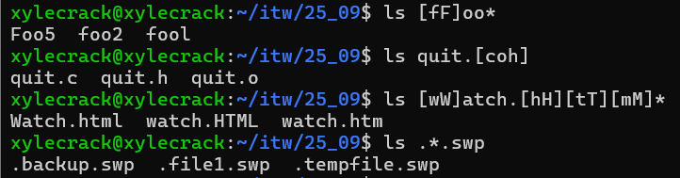2.

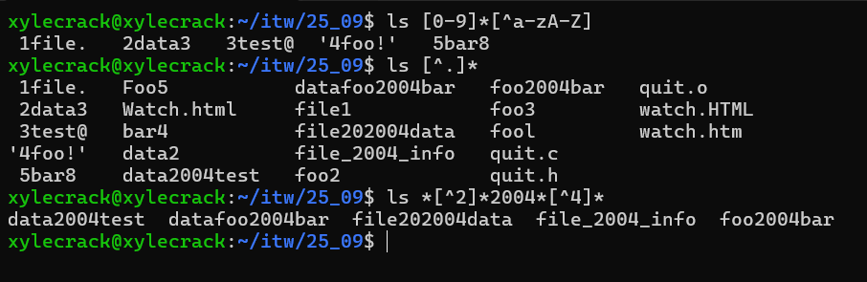

3.

**[A-z]????\***: Matches filenames where the first character is a letter (or some special characters) followed by exactly 4 characters and then any number of characters.

**\*[0-9]\***: Matches filenames that contain at least one digit anywhere in the name.

**\*[!0-9 ]**: Matches filenames that end with a character that is not a digit or a space.

**\*.[!s][!h]**: Matches filenames with a two-character extension where the first is not s and the second is not h.

4. cp chap[0-2][0-9] ..

Yes, a single wild-card pattern can match all the files named chap01 to chap26.

5. **ls .\***: Lists all **hidden files and directories** (those starting with a dot) in the current directory.

**ls *.**: Lists all files that **end with a dot** and have no extension.

